Chip back potential is the level which bulk silicon is maintained by on-chip connection, or it is the level to which the chip back must be connected when specifically stated below. If no potential is given the chip back should be isolated.

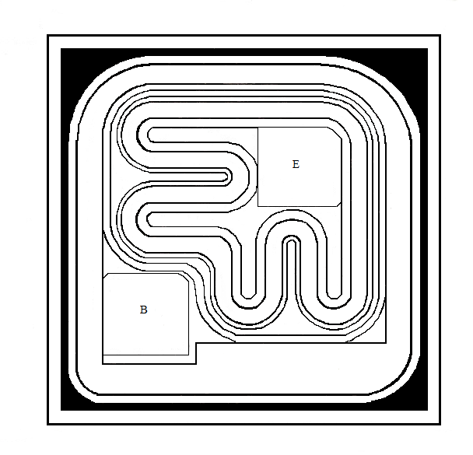
B
E
.019”
.019”

Top Material: Al
Backside Material: Au
Bond Pad Size: .004” X .004”
Backside Potential: COLLECTOR
Mask Ref: 117

APPROVED BY: DK DIE SIZE .019” X .019” DATE: 9/7/21
MFG: MOTOROLA THICKNESS .008” P/N: 2N2222A
DG 10.1.2

Rev B, 7/19/02

